Thoren Moore
Professor Vyas
IT 6203
October 15, 2026
Lab 3
Labeled Code Snippets
Project Code FormControl:
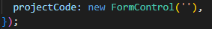
Event Binding HTML:
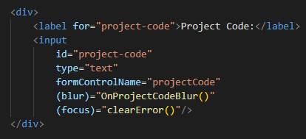
TypeScript Event Handler, Project-code Mapping Logic:
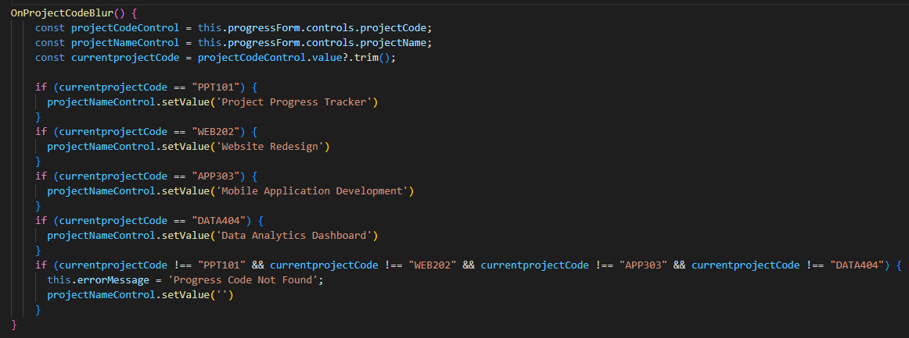
Invalid Code message:
TS:
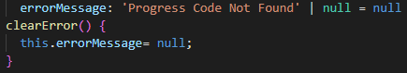
HTML:
ScreenShots:
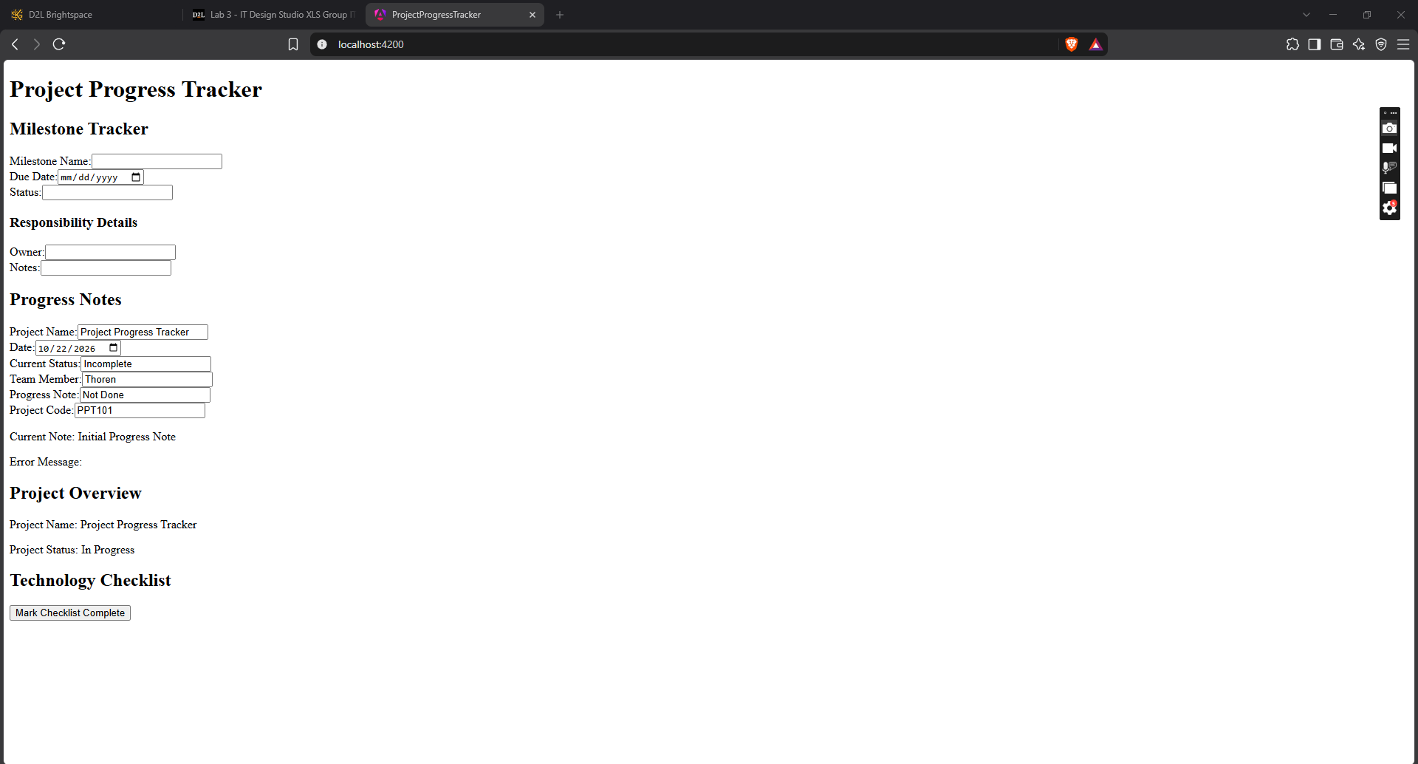
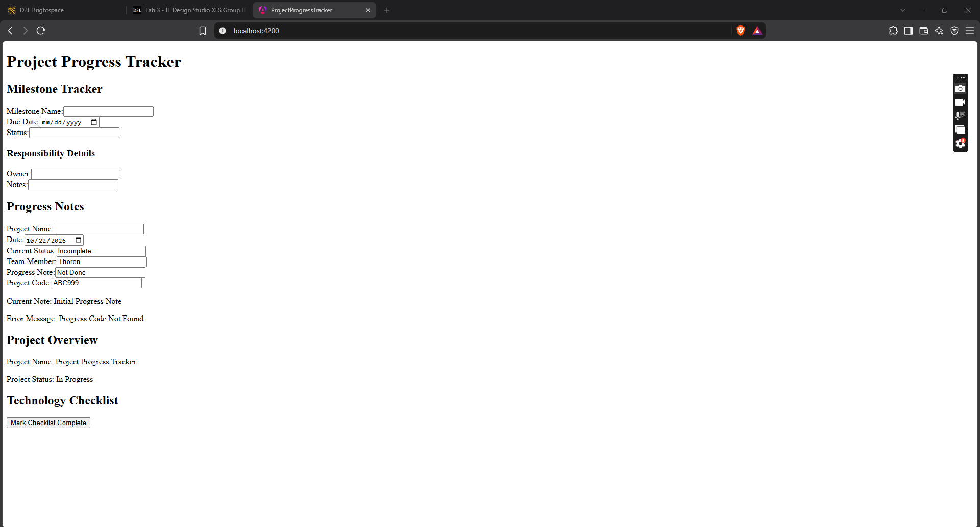
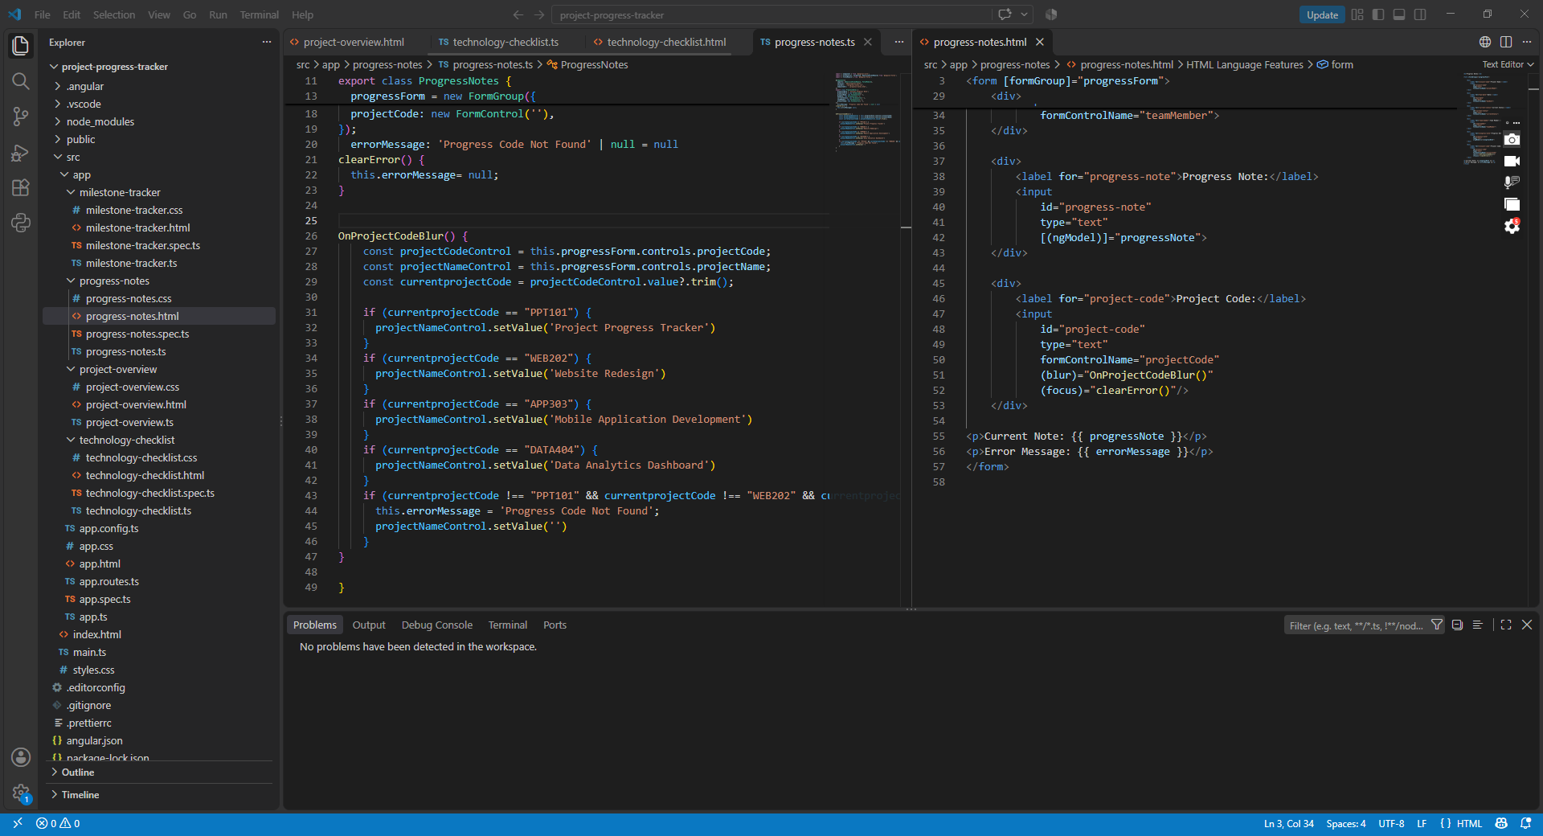
Technical Reflection:
- Using FormControls, when a blur event occurs in the project code field, Angular will run the OnProjectCodeBlur method to first check if the currently entered value in the project code field is a known project code and second change the set value for the project name form control to the string matching the entered project code.
- A problem I experienced was trying to get the error message cleared when a valid project code was entered after an invalid code was used. I fixed the problem by creating a method to clear the error when the focus event occurs after an invalid code is entered. I implemented the error message field as a paragraph element that stays empty until an error occurs. HTML decides to show the invalid code message when a blur event occurs and the project code entered doesn’t match the known project codes.

